# PS10 - Answer Sheet

|  |  |
| --- | --- |
| **Assignment:** | PS 09 |
| **Name:** | <Ranjan Behl>, <rbehl> |
| **Team-ID** | 008-14sss |
| **Contributor(s):** | <name> , <Purdue login> [repeat for each] |

## Airspeed

Paired Flowchart

Individual Programming

### Paired Partner

Each member of the pair will submit their own answer sheet. List your paired partner here.

|  |  |
| --- | --- |
| Flowchart Partner: | <John Chapla>, <jchapla> |

### High-Level Flowchart

Examine this high-level flowchart.



You need to create flowchart sections to do the following:

* Perform any loop initialization tasks and then calculate the atmospheric pressure and temperatures for the atmospheric model
* Perform any loop initialization tasks and then calculate the dynamic pressure and speed of sound vectors for the experimental altitudes

### Atmospheric Pressure and Temperature Flowchart

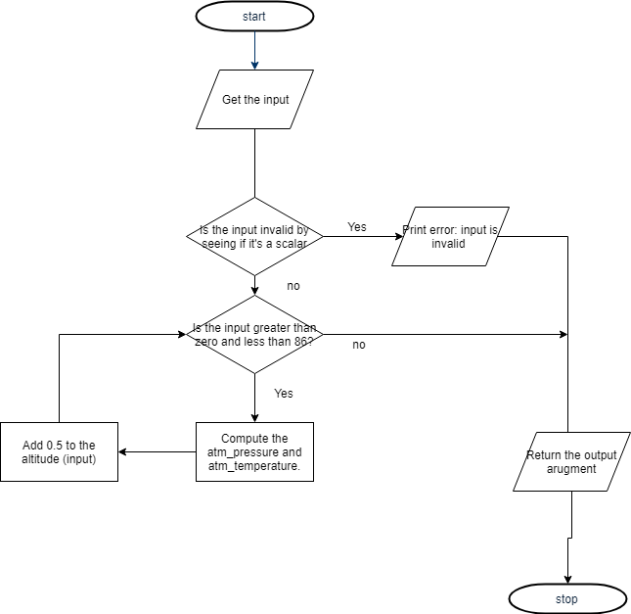

### Dynamic Pressure and Speed of Sound Flowchart

### Variable Tracking Table – by hand

Complete this tracking table, by hand, for the dynamic pressure and speed of sound flowchart section you created earlier. Add rows as necessary. Use USAtmos_1976.p to calculate the required atmospheric temperature and pressure necessary to complete the calculations. Complete this table using the vector of altitudes 22,000 ft, 28,000 ft, 32,000 ft, 36,000 ft, and 45,000 ft.

|  |  |  |  |  |
| --- | --- | --- | --- | --- |
|  | **Index** | **Altitude (km)** | **Dynamic Pressure (kPa)** | **Speed of sound (m/s)** |
| Initialization | 1 | 22000 | 4.4667e11 | 313.9319 |
| Iteration 1 | 2 | 28000 | 3.0350e11 | 306.2075 |
| Iteration 2 | 3 | 32000 | 2.3198e11 | 300.9477 |
| Iteration 3 | 4 | 36000 | 1.7560e11 | 295.5943 |
| Iteration 4 | 5 | 45000 | 1.1352e11 | 295.4738 |

## Infinite Fin Revisit

Paired

### Paired Partner

Each member of the pair will submit their own answer sheet. List your paired partner here.

|  |  |
| --- | --- |
| Flowchart Partner: | <John Chapla>, <jchapla> |

### Flowchart

## Array Sorting

Individual

### Variable Tracking Table – by hand

Complete this table for input argument $A= \left[\begin{matrix}8 & -1 & 2 \\ -5 & 8 & 6\end{matrix}\right]$. Add rows as necessary.

|  |  |  |  |
| --- | --- | --- | --- |
|  | **Row Index** | **Column Index** | **Sorted Matrix** |
| Initialization | 1 | 1 | $$\begin{matrix}-5 & 0 & 0 \\ 0 & 0 & 0\end{matrix}$$ |
| Iteration 1 | 2 | 2 | $$\begin{matrix}-5 & -1 & 0 \\ 0 & 0 & 0\end{matrix}$$ |
| Iteration 2 | 3 | 3 | $$\begin{matrix}-5 & -1 & 2 \\ 0 & 0 & 0\end{matrix}$$ |
| Iteration 3 | 4 | 4 | $$\begin{matrix}-5 & -1 & 2 \\ 6 & 0 & 0\end{matrix}$$ |
| Iteration 4 | 5 | 5 | $$\begin{matrix}-5 & -1 & 2 \\ 6 & 8 & 8\end{matrix}$$ |